GETTING PACKET TRACER FOR MAC

\*\*\*Note: You will not be able to download it in the vmware so you will need to download and save it to your piratedrive on a school computer.\*\*\*

First off you will need to download the 32bit version packet tracer make sure it saves to your piratedrive.

The vmware client is called VMware Horizon Client.

This is the website: <https://my.vmware.com/web/vmware/info?slug=desktop_end_user_computing/vmware_horizon_clients/4_0>

\*\*\*NOTE: If you live off campus you will need the VPN, but if you live on campus you will need to connect to the buccaneer wifi.\*\*\*

Also, you need to install cisco vpn client. You will have to go to:

<https://piratesvpn.ecu.edu>

You will sign in just like you would to blackboard or your email so using you pirateID and password. It will check to see that you have the correct version of java installed. Then you just need to click on AnyConnect VPN.

Once you have installed both the vmware client and vpn. Open the vpn it should look like this:

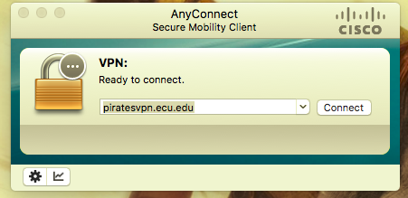

It’ll need a server to connect to which is in the picture above. piratesvpn.ecu.edu

When you have connected to the vpn open vmware horizon client. It’ll look something like this:

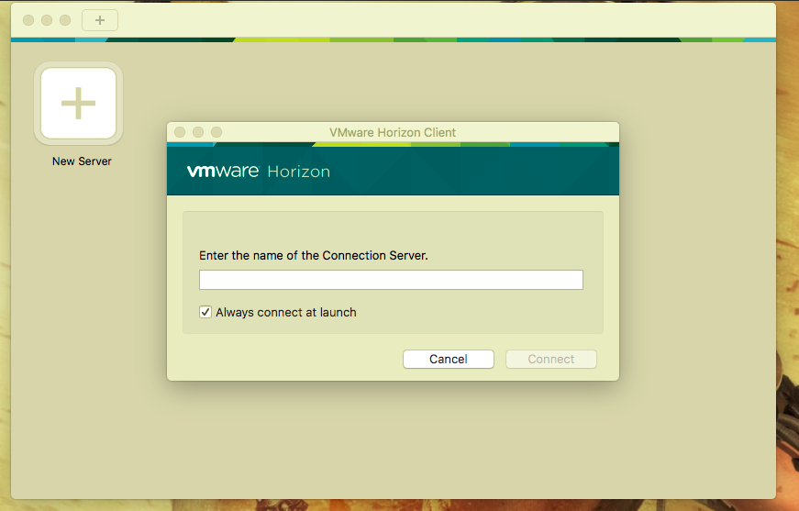

So, where it asks for the name of the Connection Server type in – tecsview.ecu.edu

A login prompt will pop up make sure your domain is selected as INTRA before clicking login. Then you select one of the choices listed.

Well that's pretty much it. If you have any problems let me know.